

GROWING TOGETHER
Action Planning

A Facilitator’s Toolkit

CONTENTS
Objective of the Toolkit …….……………………………………………………………………………………………… Pg 3

BEFORE THE ACTION PLANNING WORKSHOP
Preparing for the Workshop ………………………………………………………………………………………………Pg 4

DURING THE WORKSHOP
At the Workshop………..……………………………………………………………………………………………….….. Pg 5
Points to keep in mind ……………………………………………………………………………………………………. Pg 6
Tools & Techniques
Empathy Mapping …………………………………………………………………………………………….……………… Pg 7
The 5 WHYS …………………………………………………………………………………………………………..…………. Pg 8
World Café ……………………………………………………………………………………………………………..……….. Pg 9
Creating Action Plans ………………………………………………………………………………………………………. Pg 10

AFTER THE WORKSHOP
Uploading Action Plans on Qualtrics …………………………………………………………………….…… Pg 11 -13
Plan on a Page (POAP) ……………………………………………………………………………………………….…… Pg 14

TIMELINES & REPORTING
Follow Up and Periodic Reviews …………………………………………………………………………………….. Pg 15

APPENDICES …………………………………………………………………………………………………………………… Pg 16
- HR Presentation on Action Plans
- Reading & Interpreting Scores (TTT presentation)
- Ambassadors Roles & Responsibilities
- Scores Presentation Template
- Action Planning Template
- Plan on a Page (POAP)

AN HRBP/AMBASSADOR’S TOOLKIT TO FACILITATE ACTION PLANNING

Objectives of the Toolkit

- To provide a structured approach on how you can partner with your business to drive engagement, run engaging Action Planning workshops, co-create clear action plans and measure progress.

- To empower you to drive critical steps in creating a positive engaged workforce within your Division/Function

- To provide a selection of tools and techniques you may wish to utilize to stimulate discussion and interaction during the Action Planning Workshops.

- To provide planning and reporting tools for Management & Senior Leadership reviews.

Appendix 1 gives you an overview of the Automotive Action Planning imperative – using design thinking to plan, design, and execute Action Plans across the business.

BEFORE THE WORKSHOP
Before you start the workshop sessions, it is important to have a meeting with the Leadership Team to present the business scores and ensure understanding and alignment on the interpretation of the Growing Together Scores. This session with the Leadership team should give you a high-level view on the key concerns and focus areas to keep in mind while conducting the AP workshop sessions.
The TTT presentation and the HR Templates provide useful reference on how to interpret and present the score cards:
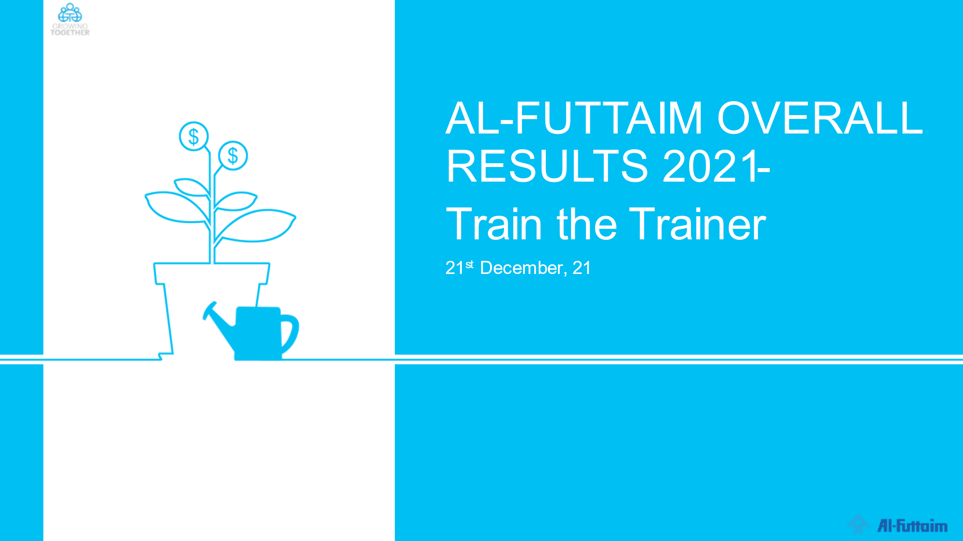 Appendix 2

IDENTIFICATION OF AMBASSADORS
To support you in conducting workshops across the business as well as to champion the follow up on Action Plans, it is imperative that you have the business identify and nominate Ambassadors from within the business. These Ambassadors should be individuals who are Influencers in the business or identified as Top Talent with strong communication skills.
A guide on the Engagement Ambassador’s roles and responsibilities is provided with this toolkit.
Appendix 3

START BY SETTING UP A SESSION SPECIFICALLY FOR THE PURPOSE OF ACTION PLANNING:
(Suggested time 3 ½ hours)
Session for Senior Leadership: Attendees should include a mixture of senior leaders and other socially influential employees (Talents) within the Division/Business Unit, ensuring there is both a representation of Business and HR.
Session for Line Managers: Attendees should include the HOD, the LM and members of the workgroup. In larger workgroups, once the focus areas have been identified, the facilitator should break them into smaller groups*

FAMILIARIZATION
It will be useful to familiarize yourself with the Work group(s) you will be facilitating. HRBPs have access to the Score Cards of the business managers and should review the score cards, the open-ended statements and heat maps etc and prepare a summary of cut and sliced data by gender, age groups, length of service, Bands etc prior to the workshop. It is important to look for trends and correlations across the categories.
The Ambassador(s) should attend the initial Workshop with the HRBP as facilitator to be able to observe and learn before they can run the workshops themselves. It is advisable that you observe the Ambassador when they facilitate to provide support and constructive feedback. A copy of the Guide should also be shared with the Ambassadors.

AT THE WORKSHOP
YOU WILL NEED
Flip charts, markers, post-its. Familiarization with the Tools & Techniques coupled with a great attitude and you’re ready to begin.

WELCOME PARTICIPANTS & INTRODUCE THE OBJECTIVE AND AGENDA FOR THE SESSION:
INTERPRET THE RESULTS OF THE SCORE CARD:
(Use the presentation template provided)
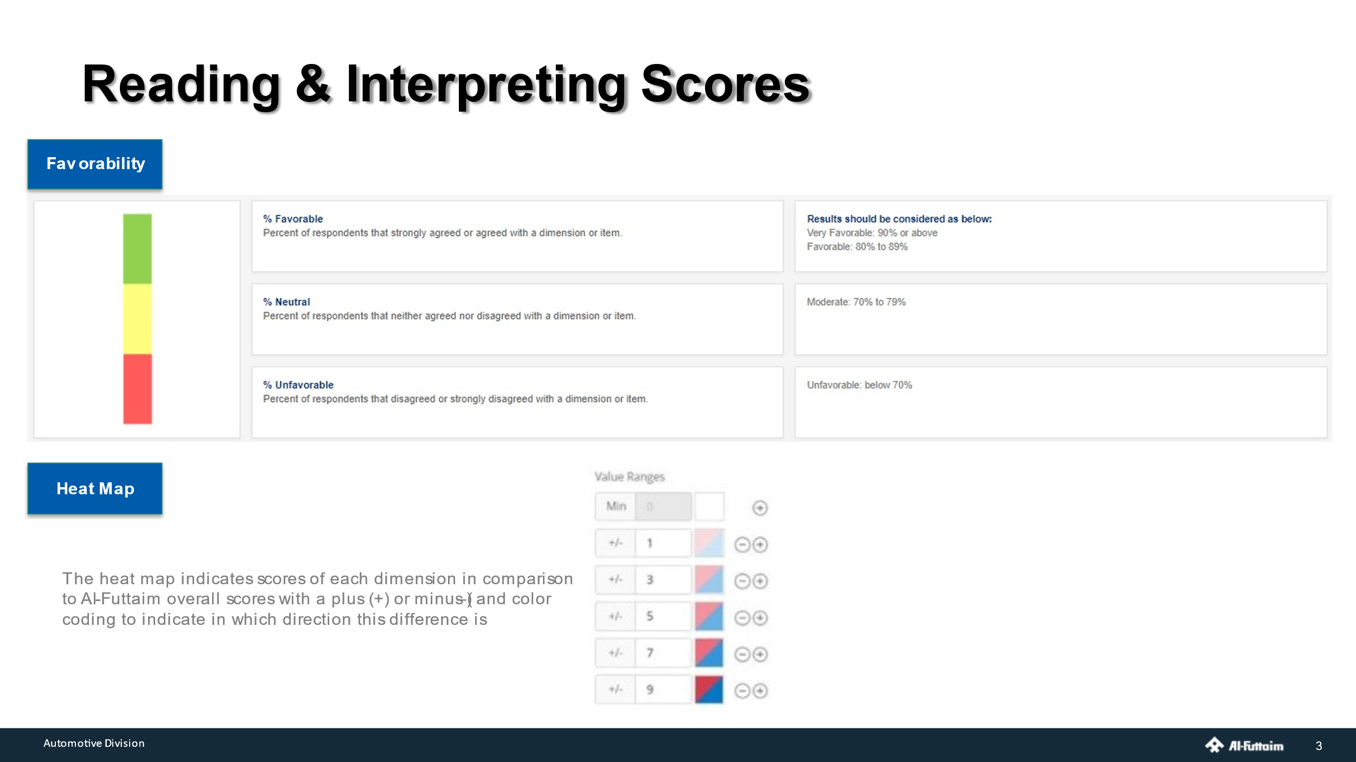 Appendix 4

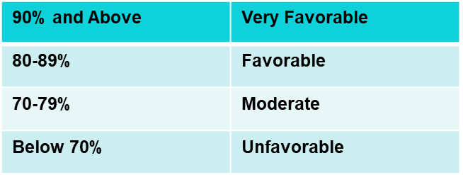
You may go through the dimension scores and analyze and compare the scores from 2020 and 2021. You may also compare the team scores with regards to the Group overall scores and the external benchmark provided.
You may also slice the data with various cuts such as gender, age groups, countries, brands etc. to get granular in your analysis
It is highly recommended to go through the open-ended statements for interpreting the underlying sentiments of your employees
Top 10 statements help you understand your areas of great work and bottom 10 statements signify areas where you may need to start putting your focus.
All color shadings on the dashboards are relative to the Group scores. The more negative deviation the color tone turns red and shades of red and with more positive deviations the color tone turns green and shades of green.

Some important points to keep in mind while facilitating the sessions:

- The session with the Leadership Team has provided you with some key focus areas that are of primary concern to the business. While communicating this to the work groups at the start of the workshop, it is not mandatory for the workgroup to Action Plan only on those areas. It is however, recommended that at least one or two of the 4 Action Plans must address those focus areas while the others would focus on issues most relevant and important to the work group.

- Plans made by the work groups must always be based on actions that are within the circle of influence of the individuals in the work group. For example: Action Planning around a policy issue which the associate has no control or influence over is not recommended.

TOOLS & TECHNIQUES

EMPATHY MAPPING
Empathy Mapping helps the team build a stronger understanding of the reality that is being experienced by the employees, as it relates to the subject identified.
It supports the team in taking a holistic view of how the subject discussed, is appearing and impacting them.
Start off by defining the subject you are building the empathy map around.
Split the group into smaller teams and provide Post-it Notes to the teams
Invite each team member to utilize their post it notes to capture their observations. Remind them that they are representing the wider team, so their comments can also stem from observations of others.
Prepare a flip chart indicating the quadrants as below:
2. WHAT ARE PEOPLE HEARING?
Ask team members to capture :

What is being said and shared about this subject?
How and from where are they hearing this information?

1. WHAT ARE PEOPLE THINKING AND FEELING?
Ask team members to capture:

Employee’s emotions and feelings.
What really matters to the employee, what are their major concerns as it relates to the subject?

3. WHAT ARE THE PEOPLE SEEING?
Ask team members to capture :

What actions or behaviors are employees seeing as it relates to the subject?
What are they seeing happening in the external environment/ competitors?
Is what they are seeing, matching what they are hearing?

4. WHAT ARE PEOPLE SAYING AND DOING?
Ask team members to capture :

What are employees actually saying about the subject?
Has any action been taken about the subject
Is there a coherence between what is said and what is done.

Ask participants to note down one observation per sticky note, and then place these in the respective quadrant in the flip chart.
Once complete, collate Post-its with similar comments and summarize the key findings for the debrief.
PICK THE KEY FINDINGS FROM THE EMPATHY MAP AND PROCEED WITH THE 5 WHYS

5 WHYS

STEPS FOR THE 5 WHYS
(Note: It is likely that the Empathy Mapping and the 5 WHYs will overlap at some points)

- Define the Problem:
Write the problem statement on the whiteboard/ flip chart, leaving enough space around it to add the answers to the repeated question, "Why?“

2. Ask the First Why
Asking "Why?" sounds simple, but answering it requires serious thought. Search for answers that are grounded in fact: they must be accounts of things that have actually happened, not guesses of what might be happening. Your team members may come up with one obvious reason why, or several plausible ones. Record their answers as succinct phrases, rather than as single words or lengthy statements, and write them below (or beside) your problem statement. For example, saying “line managers do not explain rationale behind every decision " is better than a vague “managers are unclear”.

- Ask why 4 more times:
For each of the answers that you generated in Step 2, ask four further "whys" in succession.
Each time, frame the question in response to the answer you've just recorded.

- Know when to stop

You'll know that you've revealed the root cause of the problem when asking "why" produces no more useful responses, and you can go no further. If you identified more than one reason in Step 3, repeat this process for each of the different branches of your analysis until you reach a root cause for each one.

WORLD CAFÉ
Once you have completed the first two workshop techniques, it is necessary to use this technique to get a cross section of thoughts and ideas to enrich the action plans.
(While you may not use the exact café seating here, the room should be set up to enable the workgroup to break for discussions into smaller groups)
World Café methodology is a simple, effective, and flexible format for hosting large group dialogue. Each element of the method has a specific purpose and corresponds to one or more of the design principles.
Have the teams to create Action Plans using this methodology

- SETTING
Create a “special” environment, most often modeled after a café, i.e. small round tables. There should be four chairs at each table (optimally) – and no more than five

- SMALL GROUP ROUNDS
The process begins with ten-minute rounds of conversation for each of the groups of people seated around a table. At the end of the ten minutes, each member of the group moves to a different new table. One person stays behind as the “table host” for the next round, they welcome the next group and briefly fill them in on what happened in the previous round.

- QUESTIONS
Each table will pose the question of, What can be done to address the Root Cause/s identified in the 5 Whys exercise. Each round will build upon earlier ideas. The final round will focus on consolidated the actions to take forward.

- HARVEST
At the end of the 3 rounds, each Table Host will share the action plan that has been co-created on their table. Have the Hosts write down their Action Plans on a flip chart.

IT IS IMPORTANT AT THE END OF THIS STAGE TO SET THE CONTEXT AROUND EACH OF THE ACTION PLANS AND ASK THE TEAMS TO DEFINE WHAT SUCCESS LOOKS LIKE.
An ACTION PLANNING TEMPLATE is provided to start creating the work group’s Action Plans.

ACTION PLANNING TEMPLATE

Before uploading the Action Plans on Qualtrics, it is necessary to use the ACTION PLANNING TEMPLATE provided in this toolkit.

This template will help define the selected action plans, define what success on those plans look like, and place ownership on specific associates to implement, monitor and drive the actions to successful outcomes.

Appendix 5

A few examples are also provided in the template to help you get started.

While creating the Action Plans keep in mind the principle of “SMART” – not unlike objectives, these Action Plans need to be Specific, Measurable, Agreed, Resourced and Timebound.

The work group completes the ACTION PLANNING TEMPLATE as the last stage of the Workshop.

End of Workshop

AFTER THE WORKSHOP

UPLOADING THE ACTION PLANS ON QUALTRICS:

(This part of the exercise can be completed post the workshop session by the LM & his team members. Ideally, these plans should be uploaded by the LM)

Action Plans Cascade:
- Action Planning will be done across all levels in the Automotive group.
- At the Divisional level, the Actions Plans of SMD with his DRs, for example, will most likely mean that the individual MDs of each brand/business will have at least one cascaded plan reflected in his/her own Action Plans.
- Similarly, it is expected that each Line Manager will also be part of an Action Plan cascade from their MD/HOD.
- Therefore, in addition to the Action Plans for the work group, it is expected that a Line Manager will have an Action Plan which is part of the leadership cascade, and this should reflect in their Action Plan upload on Qualtrics.
- However, this is not part of the Workshop session for the workgroup.

Guidelines for uploading the Action Plans:

Access your Page on Qualtrics and go to “Action Plans”
Choose the + Action Plan (top right hand corner) button to create an Action Plan.

From the drop down, select a focus area for the plan: These could be as follows:
- Survey question
- Categories
- None
Then select an item from the chosen focus area.
In the example below the selection is made from the Survey Question # 18 – pertaining to communication…
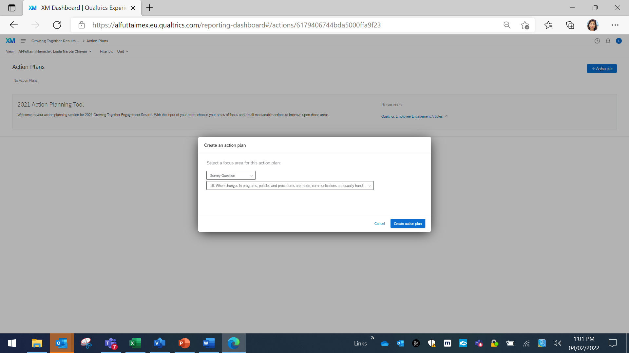
Thereafter the Action Plans created in the workshop session are transcribed in the system

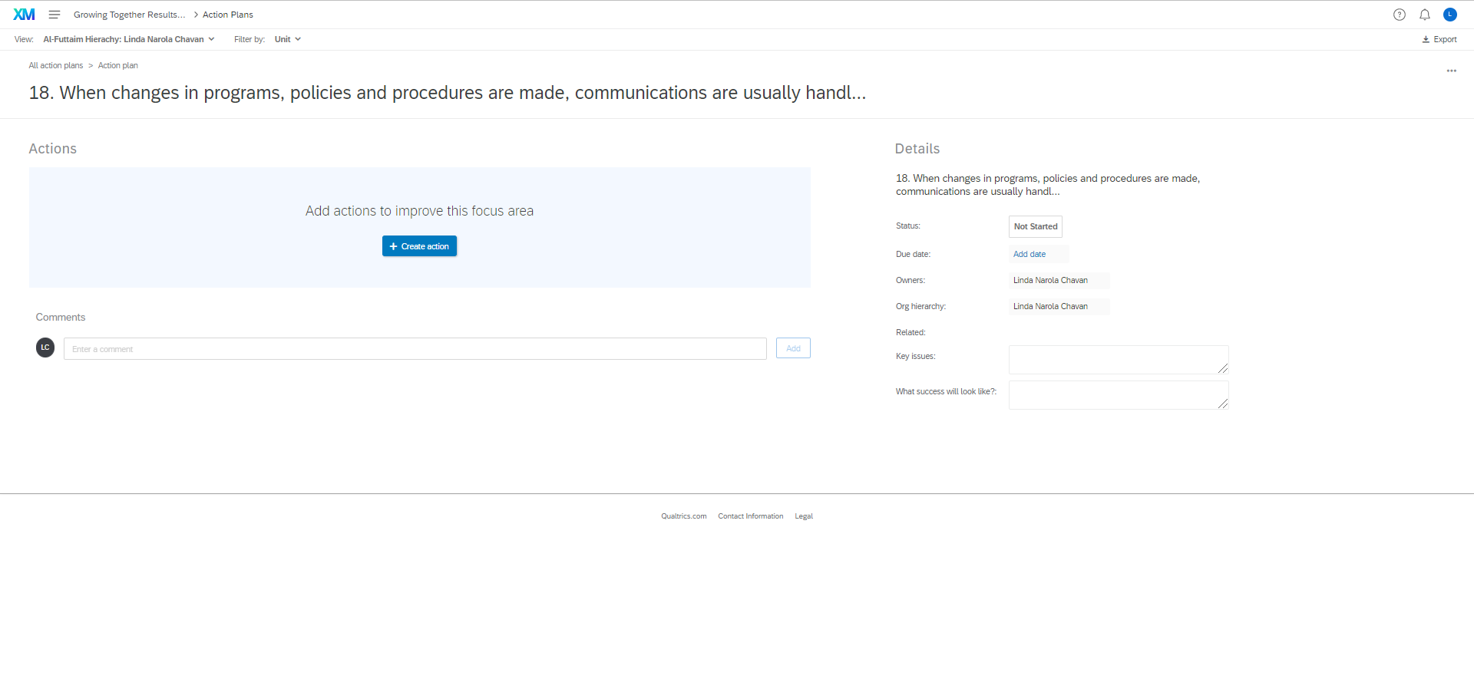

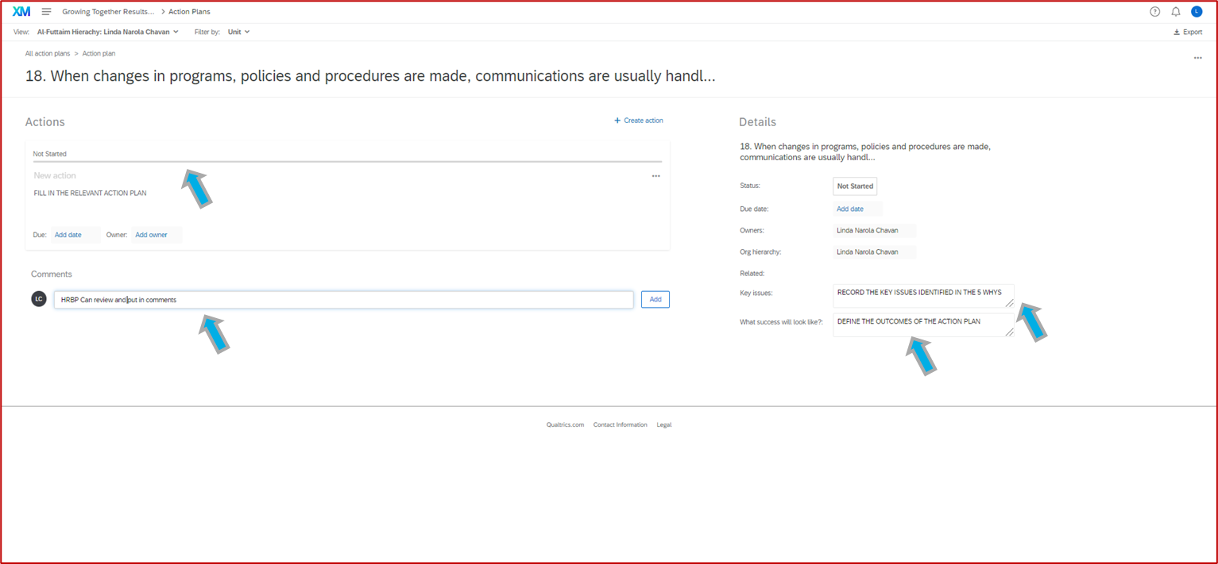

Once the Action Plans have been completed in Qualtrics by the LMs, it is advisable for the HRBPs to review these in the system to ensure that the agreed Action Plans have been captured in their entirety and essence as reflected in the Action Planning Template. HRBPs may put their comments below the Plan.

PLAN ON A PAGE [POAP]

After completing the Action Planning Templates the plans will need to be put into the POAP for ease of tracking and ensuring adherence to the timelines and deliverables of the plans. This step will be completed by the Line Manager. The Action Plans should be transposed on the POAP with specific timelines for each Action Plan.

Appendix 6

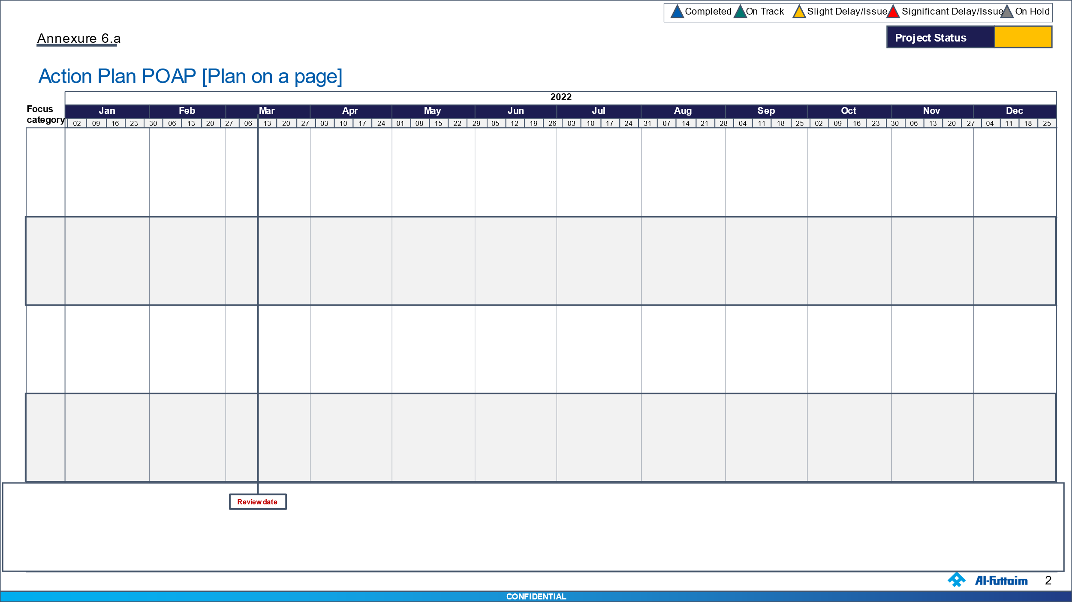

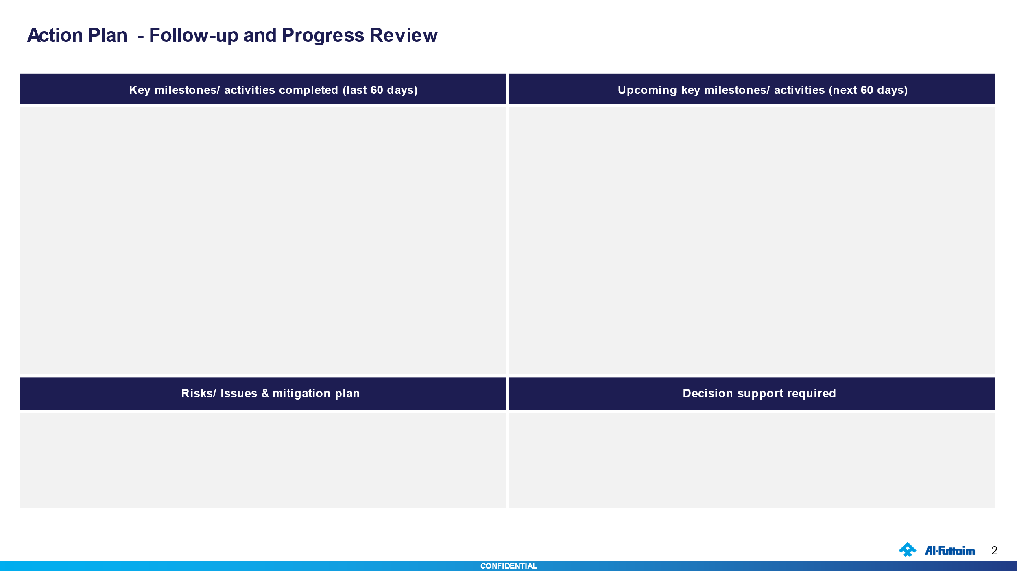

Some examples are provided for your easy reference.

The POAP is recommended to be used to report on progress at the SBU and Divisional level periodic review meetings.

FOLLOW UP AND PROGRESS REVIEW MEETINGS

It is recommended to have review meetings by HRBP/Ambassadors at the SBU level on progress once every 2 months. Line Managers can determine the periodicity of reviews with the workgroup if required more frequently. MD/HRBP for the respective businesses will be required to submit/present their POAPs for/at the Divisional Level Engagement Reviews.

Timelines for the Employee Engagement Program
Date | Description | Responsible
15th to 28th February | Identify and assign Departmental Ambassadors  Arrange and run Engagement Workshops  - Review draft impact plan at entity level  - Business Operations review at MDs/SMD level  - Automotive Leadership review by President/CoEs/Execs | Ambassadors, Line Manager, MD, SMD, COEs, Execs  HRBP to Facilitate
15th March | Finalise Action plans for  - Entity level  - Business Operations - MDS/SMD level  - Automotive Leadership - President/CoEs/Execs | Ambassadors, Line Manager, MD, SMD, COEs, Execs
15th February – 31st March | Arrange and run Engagement Workshops  - Line Manager/Departmental level  Create and finalise Engagement Communication plans for  - Entity level  - Business Operations - MDS/SMD level  - Automotive Leadership - President/CoEs/Execs | Ambassadors to Facilitate with HRBP support
31st March | Upload the Line Manager impact plans in the Qualtrics | Line Managers
1st April – 30th April | Impact plans to be translated into POAP at  - Line Managers  - Entity level  - Business Operations - MDS/SMD level  - Automotive Leadership - President/CoEs/Execs
1st Review: 30th April  2nd Review: 30th June  3rd Review: 31st Aug  4th Review: 31st Oct  Bi-Monthly starting from April last week | Impact and communication plan review | MD, SMD, President

APPENDICES

Appendix 1
Auto Group HR Action Planning Presentation

Appendix 2
Reading & Interpreting Scores (TTT presentation)

Appendix 3
Ambassadors Roles & Responsibilities

Appendix 4
Engagement Scores Presentation Template

Appendix 5
Action Planning Template

Appendix 6
Plan on a Page (POAP) Template

